Team 16

Members:
Sergio Coria Maya
Christopher Lei Bossle Mendes

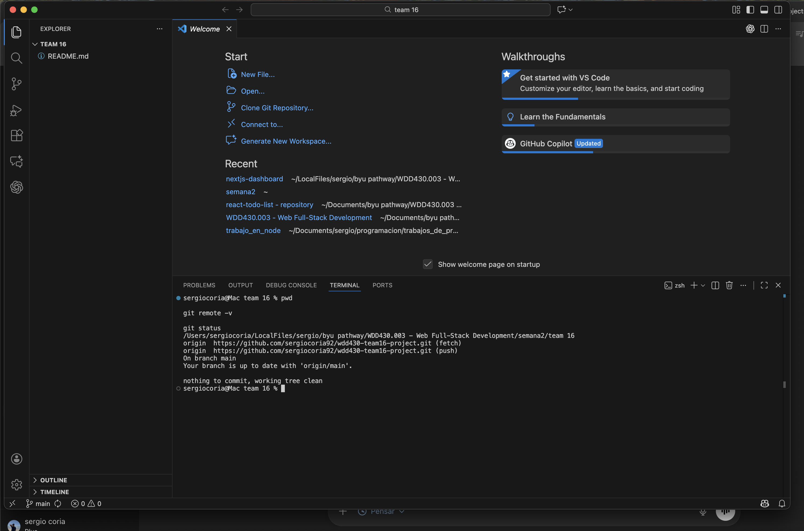
Copy of repository on Sergio Coria’s PC:

Theme (docs/theme.md):
# Theme / Design (basic)

- Background: #121212 (dark)
- Primary color: #1DB954 (green accent)
- Text: #FFFFFF (main) / #B3B3B3 (secondary)
- Font: Inter (or system default if not available)
- Style: simple dark UI, rounded corners (10px), clean spacing

10 Work Items:

- Decide Project Idea (MVP)
Description: Brainstorm 2–3 ideas and choose one. Write a 2–3 sentence description of the app and the main goal.

- Define Target Users
Description: Identify who will use the app (example: students, families, small teams). List 2–3 user needs/problems we want to solve.
- List Core Features
Description: Create a short MVP feature list (5–8 items). Mark what is “must-have” vs “nice-to-have”.
- Create Basic Wireframes
Description: Sketch simple wireframes for Home + one main page (mobile + desktop). Keep it minimal and clear.
- Set Up Repo Structure
Description: Create the initial folder structure and add a basic README section for setup instructions (install/run/build).
- Initialize React App
Description: Create the React project (Vite or Next.js depending on team choice). Verify it runs locally.
- Add Routing + Page Skeletons
Description: Add basic routes and placeholder pages (Home, About, Main Feature page). Ensure navigation works.
- Apply Basic Theme
Description: Add the basic theme (dark background, green accent, Inter/system font). Create global styles and test on pages.
- Build First Reusable Component
Description: Create one reusable UI component (Card/List/Button). Use it on at least one page with sample content.
- Team Sync + Next Leader
Description: Document meeting notes and assign tasks. Decide the next meeting leader and add their name in the README.

GitHub:
https://github.com/sergiocoria92/wdd430-team16-project

